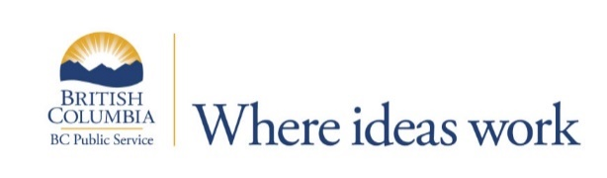
Ministry of Forests, Lands, Natural Resource Operations and Rural Development
This position is located in Fort St. John; however, Fort Nelson and Dawson Creek may be considered based on operational considerations.
Senior First Nations Relations Advisor
$71,298.93 - $81,387.14 annually
The Senior First Nations Advisor conducts and provides leadership on First Nations consultation for a wide range of individual and coordinated statutory authorizations associated with the use of natural resources on Crown Land in the Northeast region. The position examines applications, including controversial proposals of high economic value, to determine impact on First Nations’ Treaty rights and Aboriginal rights, and carries out consultation according to consultation policy and ratified agreements to address First Nation concerns. This work includes facilitating meetings and correspondence, building relationships with regional First Nations, resolving conflicts on a range of complex issues, advising ministry and industry on consultation requirements and providing recommendations to statutory decision makers on how these projects and initiatives should proceed with respect to First Nation’s rights and interests.
The Senior First Nations Advisor also leads and supervises other consultation staff and/or resource officers in the implementation of consultation. This will involve providing direction, coaching and training to direct supervisors as well as indirect staff regarding consultation processes and assist them in consultation and conflict resolution when required. This position may also require coordination and interface with other Ministries in negotiating agreements and assist in the implementation of those agreements.
The BC Public Service is an award-winning employer and offers employees competitive benefits, amazing learning opportunities and a chance to engage in rewarding work with exciting career development opportunities. For more information, please see What We Offer.
The BC Public Service is committed to creating a diverse workplace to represent the population we serve and to better meet the needs of our citizens. Consider joining our team and being part of an innovative, inclusive and rewarding workplace.
Qualifications for this role include:
- Master’s Degree in natural resource management, public administration, business administration, law or other relevant discipline and at least one (1) year of recent related experience; OR,
- Bachelor’s Degree in natural resource management, public administration, business administration, law or other relevant discipline and three (3) years of recent related experience; OR,
- An equivalent combination of education, training and experience may be considered; AND,
  - Recent experience is defined as experience gained within the last five (5) years.
- Recent, related experience must include the following:
  - Experience conducting research and analysis related to land use, resource management, social or economic development issues.
  - Experience working with First Nations communities and leading First Nations consultations.
- Preference may be given to candidates with supervisory experience.
For more information and to apply online by February 1, 2021, please go to: https://bcpublicservice.hua.hrsmart.com/hr/ats/Posting/view/73854

