Welcome to the 2019 3M National Student Fellows
**La version française suit**
The Council of 3M National Fellows for Teaching and Learning in Higher Education is delighted to welcome the 10 recipients of the 2019 3M National Student Fellowship into our community. Congratulations to these outstanding students and future leaders!
It will be a pleasure to welcome them in person at the STLHE conference in June in Winnipeg, and to celebrate them with great pride at the 3M National Fellows Reunion dinner on June 12, 2019.
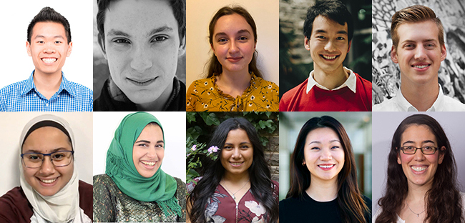
The 2019 3M National Student Fellows:
Mathieu Chin, Biomechanics, University of Calgary
Mathew Dueck, Indigenous Social Work, Laurentian University
Taylor Irvine, Study of Religion, University of Toronto
Owen Dan Luo, Child Health and Health Sciences, McMaster University
Ethan Pohl, Sociology (Criminology, Law, and Social Policy) and Political Studies, Bishop's University
Mariam Ragab, Computer Science, and Sociology and Social Anthropology of Social Justice and Inequality, Dalhousie University
Hayat Showail, Environment, Sustainability & Society, Dalhousie University
Tonya-Leah Watts, Biomedical Science and Indigenous Studies, Trent University
Tingting Yan, Health Sciences, Biomedical Sciences, University of Calgary
Enav Zipora Zusman, Pharmacy, University of British Columbia
Congratulations to all involved, and a special thanks to our new 3MNSF awards coordinator, Cynthia Korpan.

